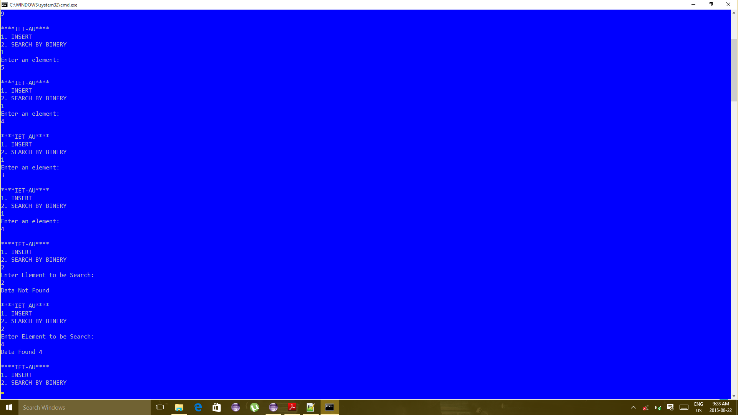

Figure 1Here first of all I have insert {9,5,4,3,4} then I search {2} but data not Found and then I Search {4} thus Data is Found

Here first of all I have insert {9,5,4,3,4} then I search {2} but **data not Found** and then I Search {4} thus **Data is Found**

you may see in screenshot

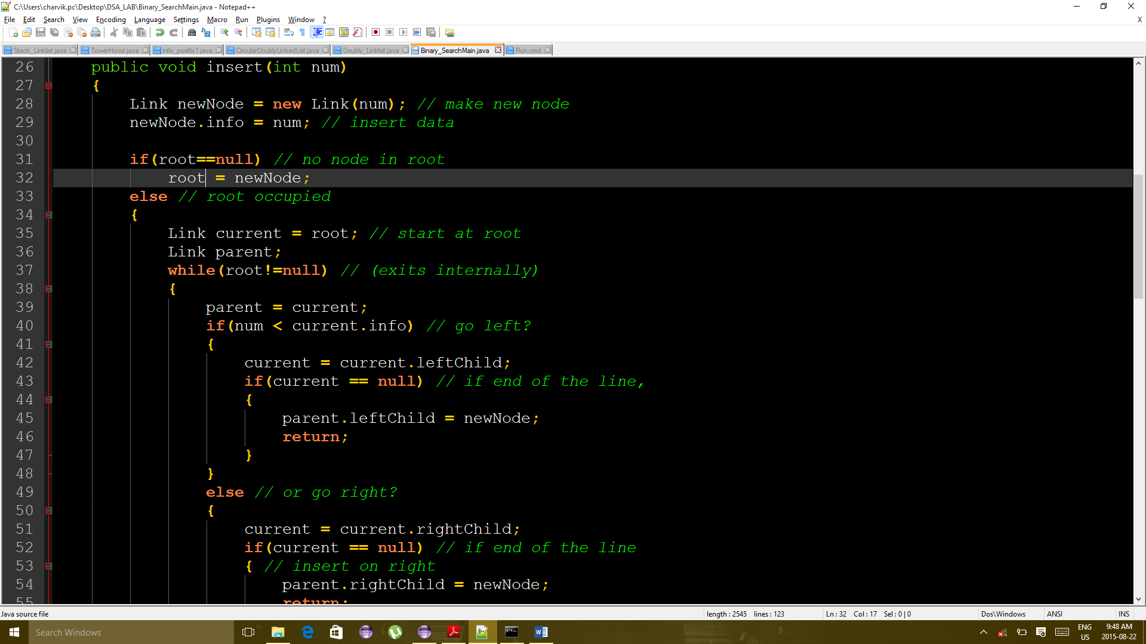

CODE OF ISERTING ELEMENT

Figure 2CODE OF ADDIND ELEMENT

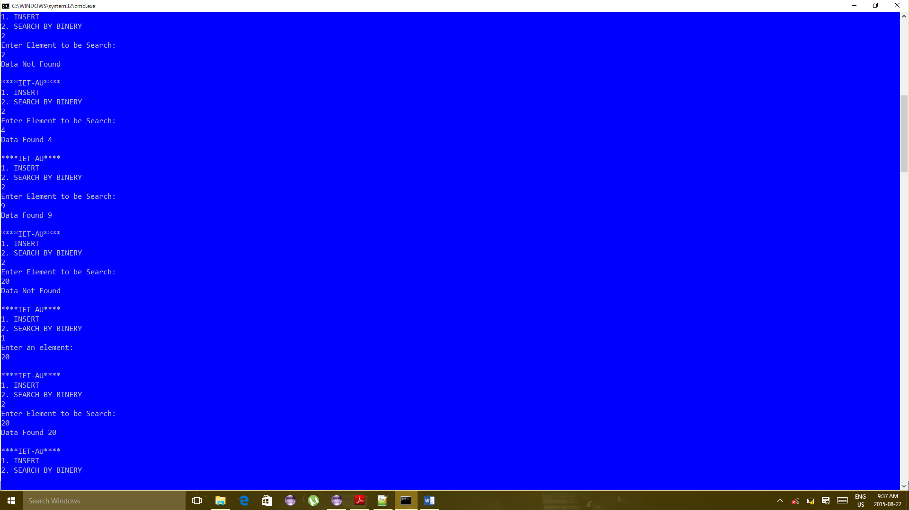

Here before adding the data {20} I have search in List thus its show **Data not Found** ,

After and Inserting Data {20} I have Search in List And **Data Found**

**That you can see in screenshot**

Figure 3 Here before adding the data {20} I have search in List thus its show Data not Found ,

After and Inserting Data {20} I have Search in List And Data Found